**Sketch**

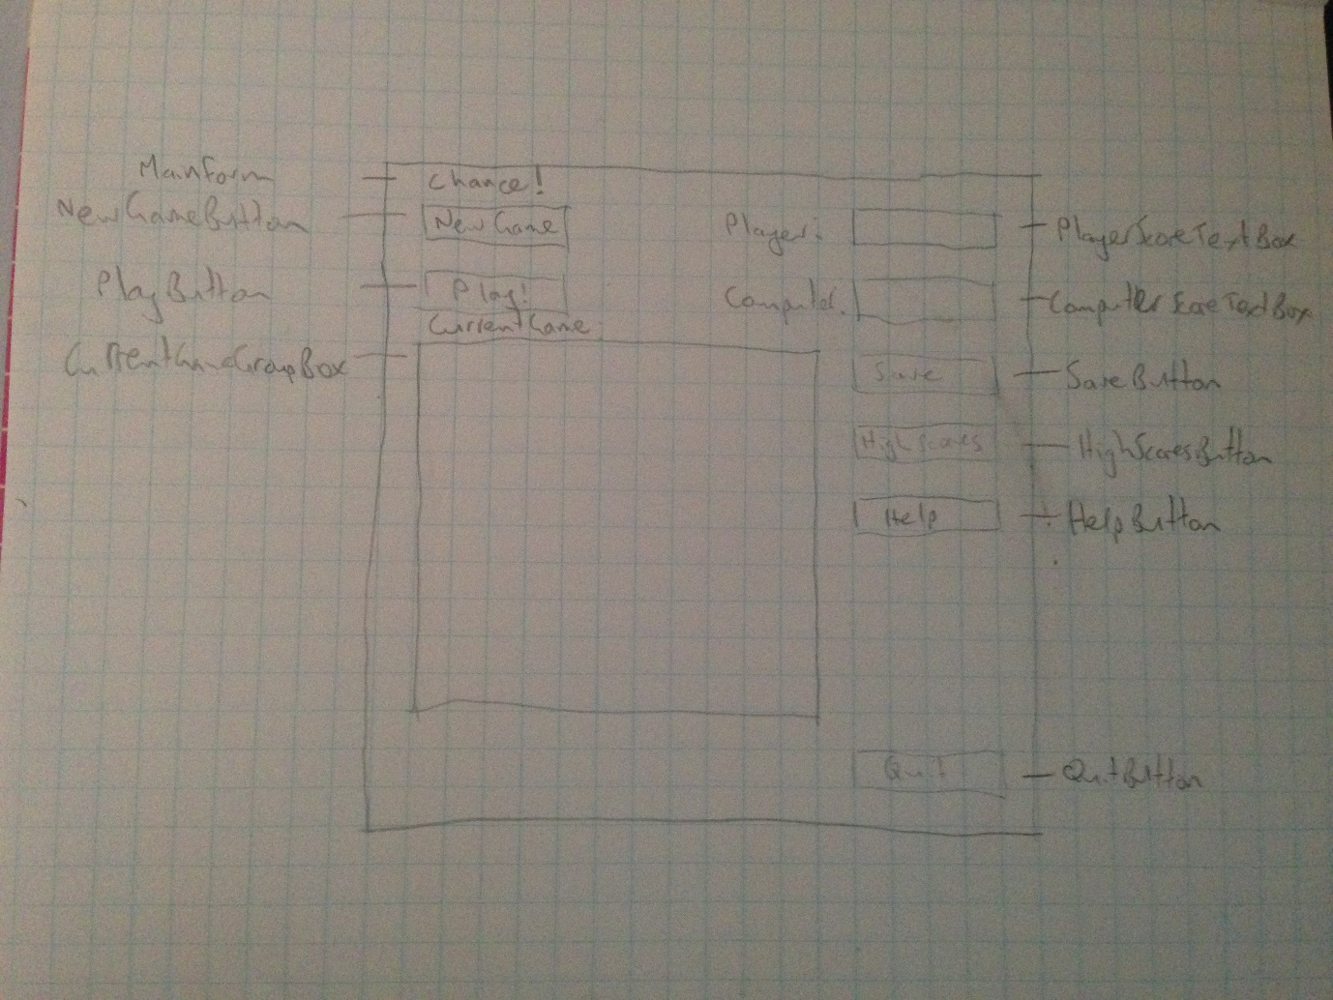

**Objects and Properties - GameForm**

|  |  |  |
| --- | --- | --- |
| **Object** | **Property** | **Value** |
| GameForm | AcceptButton | PlayButton |
|  | CancelButton | QuitButton |
|  | Text | “Chance!” |
| NewGameButton | Text | “New Game” |
| PlayButton | Text | “Play!” |
|  | Enabled | False |
| CurrentGameGroupBox | Text | “Current Game” |
| PlayerLabel | Visible | False |
|  | Text | PlayerNameString |
| ComputerLabel | Visible | False |
|  | Text | “Computer:” |
| PlayerScoreTextBox | Visible | False |
|  | Text | PlayerScoreInteger |
| ComputerScoreTextBox | Visible | False |
| ComputerScoreTextBox | Text | ComputerScoreInteger |
| SaveButton | Text | “Save” |
|  | Enabled | False |
| HighScoresButton | Text | “High Scores” |
| HelpButton | Text | “Help” |
| QuitButton | Text | “Quit” |

**Event Procedures - GameForm**

|  |  |
| --- | --- |
| **Procedure** | **Action** |
| NewGameButton_Click | Clear game board  Reset PlayerScoreInteger  Reset ComputerScoreInteger |
|  | If there is a current game still in progress:  Ask for confirmation to create new game |
|  | Display NewGameDataForm with ShowDialog() |
|  | Dynamically create game board based on NewGameDialogBox values using this code: <http://checktechno.blogspot.com.au/2012/11/add-control-in-your-form-dynamically.html> |
|  | Enable PlayButton |
|  | Show PlayerLabel |
|  | Show ComputerLabel |
|  | Show PlayerScoreTextBox |
|  | Show ComputerScoreTextBox |
| PlayButton_Click | Choose index from array for player |
|  | Add value to PlayerScoreInteger |
|  | Choose index from array for computer |
|  | Add value to ComputerScoreInteger |
|  | If no more indexes available:  Enable SaveButton  Display GameOverDialogBox |
| HighScoresButton_Click | Display HighScoresDialogBox with list of player names and highest score achieved |
| HelpButton_Click | Display HelpDialogBox with play instructions |
| SaveButton_Click | Save current game to file |
| QuitButton_Click | Exit the game |

**Objects and Properties - NewGameDataForm**

|  |  |  |
| --- | --- | --- |
| **Object** | **Property** | **Value** |
| newGameDataForm | AcceptButton | StartGameButton |
|  | CancelButton | CancelButton |
|  | Text | “New Game” |
| PlayerNameLabel | Text | “Enter your name:” |
| GameBoardRowsLabel | Text | “Number of rows:” |
| GameBoardColumnsLabel | Text | “Number of columns:” |
| StartGameButton | Text | “Start Game” |
| CancelButton | Text | “Cancel” |

**Event Procedures - NewGameDataForm**

|  |  |
| --- | --- |
| **Procedure** | **Action** |
| StartGameButton | Pass PlayerNameString, GameBoardRowsInteger, GameBoardColumnsInteger back to GameForm |
|  | Close NewGameDataForm |
| CancelButton | Close NewGameDataForm |